**Software Requirements Specification**

**for**

**ATMSim**

Version: 1.0 Date: 2018/08/06



**Metatechno Lanka Company (Private) Limited.**

Level 6, "Millennium House",

No: 46/58, Nawam Mawatha,

Colombo 02, 00200, Sri Lanka.

**Document Control**

**Release**

|  |  |  |  |  |
| --- | --- | --- | --- | --- |
| **Version** | **Date** | **Change Notice** | **Pages Affected** | **Remarks** |
| V 1.0 | 2018/08/06 | Create New | All | First Release |
|  |  |  |  |  |
|  |  |  |  |  |

**Distribution List**

|  |  |  |  |
| --- | --- | --- | --- |
| **Name/Title** | **Organization** | **Category** | **Comments** |
| PM | MTL |  |  |
|  |  |  |  |
|  |  |  |  |

|  |  |  |
| --- | --- | --- |
| **Prepared By** | **Reviewed By** | **Approved By** |
| Malinda Ushan |  |  |

**Table of Contents**

1 Introduction 2

1.1 Purpose 2

1.2 Intended Audience and Reading Suggestions 2

1.3 Product Scope 2

2 Module ATMSim 2

2.1 Overall Description 2

2.1.1 Product Perspective 2

2.1.2 Product Functions 2

2.1.3 User Classes and Characteristics 2

2.1.4 Operating Environment 2

2.1.5 Design and Implementation Constraints 2

2.1.6 User Documentation 2

2.1.7 Assumptions and Dependencies 2

2.2 External Interface Requirements 2

2.2.1 User Interfaces 2

2.3 System Features 2

2.3.1 ATM Simulator - Login 2

2.3.1.1 Description and Priority 2

2.3.1.2 Functional Requirements 2

2.3.2 ATMSim - Balance Inquiry 2

2.3.3 ATMSim - Cash Withdrawal 2

2.3.4 ATMSim - Transfer Money 2

2.4 Other Nonfunctional Requirements 2

2.4.1 Performance Requirements 2

2.4.2 Security Requirements 2

2.4.3 Software Quality Attributes 2

2.4.4 Business Rules 2

**Table of Figures**

Figure 1 ATMSim - Sign In window 2

Figure 2 ATMSim - Main window 2

Figure 3 ATMSim - Balance window 2

Figure 4 ATMSim - Cash withdrawal window 2

Figure 5 ATMSim - Transfer money window 2

# Introduction

## Purpose

Purpose of this document is to identify the requirements of ATM simulator project. This document is prepared as a requirement in the training of MTL.

## Intended Audience and Reading Suggestions

Intended audience of this documents are system developers of MTL.

This document is covering core modules identified in the ATM Simulator. It covers an Overall description of the module, External interface requirements, System features, Nonfunctional requirements and Other requirements.

## Product Scope

Whole project is covered in this product. The ATM Simulator will support PIN authentication, balance inquiry, withdrawal and transfer.

# Module ATMSim

## Overall Description

### Product Perspective

ATMSim is a simulator application which simulates the functionality of a real ATM machine. PIN authorization, Cash withdrawal, Balance Inquiry and Transfer money are the basic functions that needs to be implemented.

### Product Functions

PIN authorization, Cash withdrawal, Balance Inquiry and Transfer money and other relevant support services are offered by ATMSim. Summary of the function offered at ATMSim as follows.

* Login using acc. no
* PIN authentication
* Balance inquiry
* Cash withdrawal
* Transfer money
* Print receipt
* PIN verification with Withdrawal and Transfering

### User Classes and Characteristics

ATMSim is operated by users of the bank who has accounts already with the bank. They should have some what an experience about using ATM.

* User – Normal user who uses the system to check balance, withdraw cash and transfer money.
* Admin – Who maintains the ATMSim system.

### Operating Environment

1. Microsoft Windows 8.1 or above

2. Microsoft .Net framework 4.5 or above

3. Adobe Acrobat Reader for viewing receipt (in .pdf format)

4. Intel i3 or above processor with 4GB of RAM and 100MB of free HDD space

### Design and Implementation Constraints

* Since the system is a simulator a user needs to enter the account number to sign into the system instead of a card.
* The receipt is printed to pdf file since printers are unavailable.
* User needs to verify his/her PIN before cash withdrawal or money transfer.

### User Documentation

1. ATMSim Installation manual – Soft copy in PDF format

2. ATMSim User manual – Soft copy in PDF format

### Assumptions and Dependencies

* All users are well literate of English.
* Receipt is printed to a pdf file.
* Users who registered in the system remembers their account number and PIN.
* Cannot register users from the system. Only admin can add user to the database manually.

## External Interface Requirements

### User Interfaces

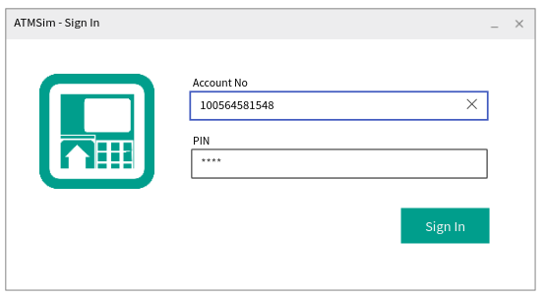1. ATMSim Login – At the start of work, user can enter to the system using their account number and PIN.

Figure 1 ATMSim - Sign In window

*Figure SEQ Figure \* ARABIC 2 Operator Cash Balance*

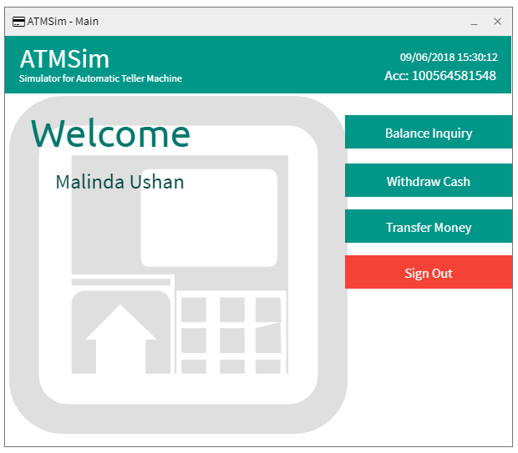2. ATMSim Main - Main interface of ATMSim which holds all the operations.

Figure 2 ATMSim - Main window

*Figure SEQ Figure \* ARABIC 3 CSC Operation*

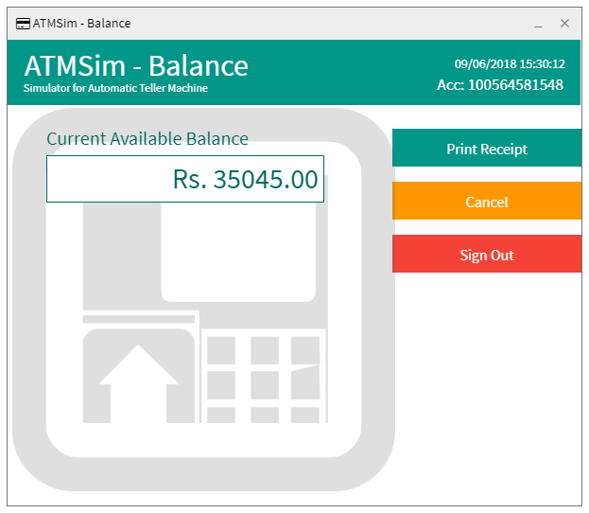3. ATMSim Balance – An interface to show balance

Figure 3 ATMSim - Balance window

*Figure SEQ Figure \* ARABIC 4 Hardware Interface*

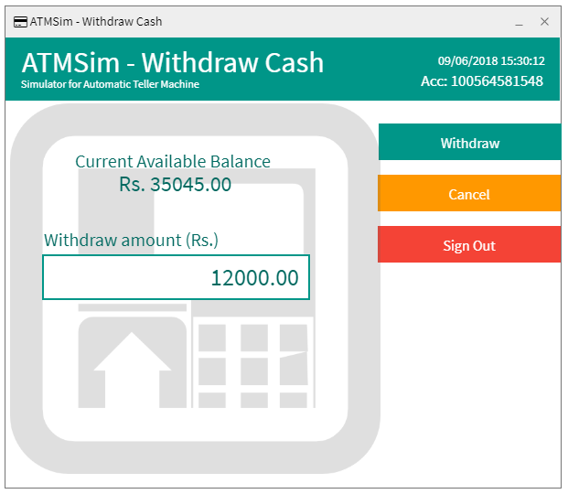4. ATMSim Withdraw – Interface for cash withdrawal

Figure 4 ATMSim - Cash withdrawal window

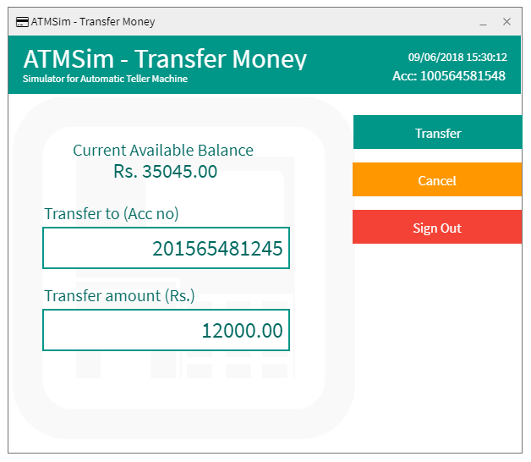5. ATMSim Transfer – Interface for transfer money

Figure 5 ATMSim - Transfer money window

## System Features

### ATM Simulator - Login

Login feature of the simulator.

Basic Flow

* + Enter account number
  + Enter PIN number
  + Click SignIn button
  + User logs into the ATMSim

Exceptions

* + If user enters a wrong account number, then system will show an error message.
  + If user enters a wrong PIN, then system will show an error message.
  + If ATMSim losses connection to the database, then the system will show an error message.

#### Description and Priority

User enters to the system using their account number and given PIN. High priority feature.

#### Functional Requirements

REQ-1: Database connectivity

REQ-2: Verification of user’s account number and the password with the system data

REQ-2: Show appropriate error messages

### ATMSim - Balance Inquiry

Feature of inquire balance of the user’s account.

Basic Flow

* + Click on Balance Inquiry button on Main Page
  + Shows Balance Inquiry Page with current balance

Alternates

* If user clicks on Cancel button system will navigate to Main Page
* If user clicks on Sign out button system will sign out the user and shows the Login Page

Exceptions

* + If ATMSim losses connection to the database, then the system will show an error message.
    - 1. Description and priority

Balance of the user’s account is shown. Normal priority.

* + - 1. Functional Requirements

REQ-1: Database connectivity

REQ-2: Printing capability to print the receipt.

### ATMSim - Cash Withdrawal

Feature to withdraw cash.

Basic Flow

* + Click on Withdraw Cash button on Main Page.
  + Shows Cash Withdrawal Page with current balance.
  + User enters an amount to withdraw.
  + Click on withdraw button.
  + Dialog Box pops up asking to print a receipt.
  + If Yes, Then

Dialog Box shows up to verify the PIN.

User enters the PIN.

Click on withdraw button.

Cash will be given to the user with a receipt.

* If No, Then

Dialog Box shows up to verify the PIN.

User enters the PIN.

Click on withdraw button.

Cash will be given to the user without a receipt.

* User will be shown a short description of transaction.
* If user clicks on Back to Main Page button system will navigate to Main Page.

Alternates

* If user clicks on Cancel button system will navigate to Main Page.
* If user clicks on Sign out button system will sign out the user and shows the Login Page.
* If user clicks on cancel button on PIN verification dialog box, then user will be navigated to current page.

Exceptions

* + If ATMSim losses connection to the database, then the system will show an error message.
  + If PIN verification failed user will be shown an error message.
  + Then user will be navigated to current page.
    - 1. Description and priority

Cash withdraw according to the balance of user’s account. High priority.

* + - 1. Functional Requirements

REQ-1: Database connectivity

REQ-2: Show current balance

REQ-3: Get user’s input of how much cash

REQ-4: Get user’s input whether to print a receipt or not

REQ-5: PIN verification

REQ-6: Issue money with appropriate change

### ATMSim - Transfer Money

Feature to transfer money to another account.

Basic Flow

* + Click on Transfer Money button on Main Page.
  + Shows Transfer Money Page with current balance.
  + User enters an account to transfer money.
  + User enters an amount to transfer.
  + Click on transfer button.
  + Dialog Box shows up to verify the PIN.

User enters the PIN.

Click on transfer button.

Money will be transferred to the entered account.

* User will be shown a short description of transaction.
* If user clicks on Back to Main Page button system will navigate to Main Page.

Alternates

* If user clicks on Cancel button system will navigate to Main Page.
* If user clicks on Sign out button system will sign out the user and shows the Login Page.
* If user clicks on cancel button on PIN verification dialog box, then user will be navigated to current page.

Exceptions

* + If ATMSim losses connection to the database, then the system will show an error message.
  + If PIN verification failed user will be shown an error message.
  + Then user will be navigated to current page.
  + If the entered account to transfer is not in the system, user will be shown an error message.
    - 1. Description and priority

Transfer money to another account. High priority.

* + - 1. Functional Requirements

REQ-1: Database connectivity

REQ-2: Show current balance

REQ-3: Get user’s input of how much cash

REQ-4: Get user’s input of to where money should transfer

REQ-5: PIN verification

REQ-6: Transfer money

## Other Nonfunctional Requirements

### Performance Requirements

* PIN authentication and verification waiting time should be kept less than 1 sec.
* Cash withdrawal process time should be kept at minimum.
* Printing receipt should finish with cash withdrawal.

### Security Requirements

* PIN number should use hash
* Cash withdrawal and Transfer money have to be go through PIN verification step.
* Possible actions should be there for SQL injection attacks.

### Software Quality Attributes

Metalanka coding rules (MTLCodingConventionsVer2.0.pdf) has to be followed when coding. C0 100% and C1 90% code coverage has to be met.

### Business Rules

* Amount that is given to withdraw cash should be multiples of 100.
* Amount enters should be between 100 and current available balance of the user’s account.
* Cash withdrawn should be convenient. (Ex: If 7600 was to be withdrawn then cash should be in 1x5000 + 2x1000 + 1x500 + 2x100 notes)

Appendix A: Glossary

ATM – Automatic Teller Machine

ATMSim - Automatic Teller Machine Simulator

MTL – Meta Techno Lanka

PIN – Personal Identification Number

SQL – Structured Query Language

REQ – Requirement

PDF – Portable Document Format

HDD – Hard Disk Drive

RAM – Random Access Memory

**CLIENT ACCEPTANCE**

Approved by the Client:

Date:

<Client>

<Client Title>